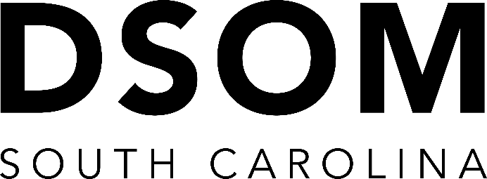

What is SCDSOM?
The South Carolina District School of Ministry is a convenient, fast track and inexpensive way to satisfy basic academic requirements for ministerial credentials with the Assemblies of God and to provide quality ministry education for staff and members of local congregations. |  | SC DSOM is endorsed by  the National DSOM Association  of the Assemblies of God.  Classes are typically held on the first Saturday of each month via Zoom.  New student enrollment fees are $75  Each course is $75  Late fees may apply  For more information  contact Molly at molly.cates@ag4sc.com

What are the advantages of SC DSOM?
Our program of studies provides personal accountability and a unique classroom environment guided by a select faculty that promotes exchange of ideas, focused dialogue, and exposure to differing perspectives on various subject matters.

How do I get my textbooks?
Students are responsible to obtain all required class materials. You may find our most recent textbook list on our website.

How do I prepare for class?
Upon enrollment, a study guide will be provided via email. Allow yourself a minimum of one month for pre-classroom preparation. This will allow enough time to read all required materials, answer all study guide questions, and study for the exam. All final exam questions will be based on your study guide.

Will I automatically receive credentials?
SC DSOM does not grant ministerial credentials. The SC AG Office provides a credential application and approval process. Our courses satisfy all basic academic standards for credentialing. For more information please contact Michelle at michelle.sandler@ag4sc.com.

